Commission on Culture and Local Government: update

Purpose of report
For information.
Summary
This paper provides an update on the Commission on Culture and Local Government, following the detailed paper which was discussed with the Board in January. The CTS Board is asked to note the paper and share their views on the key lines of enquiry.
Baroness Lola Young will be chairing the Commission and the full list of commissioners is set out in Appendix A.
Is this report confidential? Yes ☐ No X

Recommendation/s
That CTS Board Members note the contents of the report, highlight relevant case studies and share their views on the key lines of enquiry.
Action/s
Officers will incorporate the Board’s views as they develop the work of the Commission.

Contact officer: Lauren Lucas
Position: Adviser- Culture, Tourism and Sport
Phone no: 0207 664 3323
Email: lauren.lucas@local.gov.uk

Culture Commission
Background
- Councils are the biggest public funders of culture, spending over £1 billion a year in England alone. They run a nationwide network of local cultural organisations, including 3,000 libraries, 350 museums, 116 theatres and numerous castles, amusement parks, monuments, historic buildings and heritage sites.

- However, the role of councils and the contribution of local cultural organisations in our national cultural life is not always recognised at a national level. National funding for local culture is often fragmented and project based, creating challenges around sustainability.

- This independent Commission is being established by the Local Government Association to explore the contribution local council funded culture can make to Levelling Up and resilience to COVID-19 and what is needed to achieve this.

- The purpose of the Commission on Culture and Local Government is to bring together national, regional and local actors in the publicly funded cultural realm to discuss:

  - The unique role of council funded and supported culture in our recovery from COVID-19 and building back better, including its contribution to economic growth, levelling up and addressing regional inequalities; and

  - A vision for the future of council funded and supported culture in the context of place.

- The Commission’s findings and recommendations will be of interest to national and local policy makers, funders, and practitioners.

- The Commission will focus on cultural organisations and projects that are funded or otherwise supported by local authorities.
- Baroness Lola Young of Hornsey will be acting as the Chair of the Commission, which will run from March to December 2022.

Update

- Since the presentation of the detailed paper on the Commission at the last Culture, Tourism and Sport Board, there have been a number of developments.

- A group of 15 commissioners has been established to lead the work of the Commission (please see their biographies in Appendix A). They represent a range of national funders, local government leaders, arts and culture practitioners and sector experts.

- Lord Neil Mendoza, Commissioner for Cultural Recovery and Renewal has agreed to act as Advisor to the Commission, providing advice and insights on the work of the Commission at key points in its programme. This appointment has been formally confirmed by Minister for the Arts Lord Parkinson and Secretary of State for Culture Nadine Dorries, representing very positive engagement from DCMS.

- The commissioners met for the first time on the 1st March 2022 to confirm the terms of reference for the Commission and discuss the key lines of enquiry.

- The Commission was launched on Monday 7th March at the annual Hearts for the Arts Awards webinar. The LGA webpages outlining the details of the Commission are now online and we have had positive interest in response to social media posts about its work.

- We have undertaken a tender process to appoint an external supplier to offer support to the Commission in terms of 1) a stakeholder engagement programme and 2) the development of a series of briefing papers associated with the four roundtables, setting out a literature review on the key themes and producing a themed analysis of the discussion. The supplier is in the process of being appointed and these documents and research will inform the final report.
Governance
- A core group of expert Commissioners, led by an independent Chair will conduct the work of the Commission.

- The LGA Culture, Tourism and Sport Board will act as advisors to the Commission and will have representation on the core group of Commissioners (Cllr Peter Golds).

- A wider Advisory Group will be established to feed into the work of the Commission at key points. The Advisory Group will include experts able to contribute to each of the four lead propositions.

- LGA officers will provide the Secretariat for the Commission.

Implications for Wales
- The work of the Commission will have relevance to Welsh Authorities. Culture is a devolved matter, but we may include case studies from Welsh authorities in the work of the Commission.
Implications for inclusion, diversity and equality
- EDI is an important theme in the Commission, which has a strong focus on inequalities arising from Covid-19. We are incorporating this into the programme in several ways:

  - Representation – on both the core Commission and wider advisory group, which brings in a wider range of voices into the programme as well as the speakers invited to give oral evidence at the roundtables.
  - Content – in the topics under discussion at each of the four roundtables
  - Procurement – we are commissioning several pieces of work to support the Commission and have included a strong EDI focus in the RFQs.
Financial Implications
- The core costs of the Commission are met from the Board’s policy budget.
Next steps
- We will be appointing a wider advisory group to inform the work of the Commission (via the stakeholder engagement programme set out above).

- We will be tendering for a film maker to produce a set of four short films based on each of the themes of the Commission.

- The agreed key lines of enquiry will be tested and discussed at four roundtable events, to which expert practitioners will be invited to contribute as speakers. The broad propositions under discussion are:

  - Economic recovery. Publicly funded culture is essential to our national economic recovery, particularly in relation to the growth of the wider commercial creative economy and in levelling up economic inequalities between regions
  - Health inequalities. Publicly funded culture can challenge health inequalities exacerbated by the COVID-19 pandemic.
  - Social mobility. Publicly funded culture can ‘level up’ educational and skills inequalities and address challenges around social mobility
  - Place. Publicly funded culture can promote civic pride and change perceptions about a place, leading to wider social and economic outcomes.

- A theme that will also run throughout each of the four topics, is partnership. We will be testing the proposition that collaboration between national government, arms-length funders and local government at a place-based level is essential to achieve the outcomes explored in the propositions.

- The Commission’s final report will be published in December 2022.

ANNEX A
Baroness Lola Young

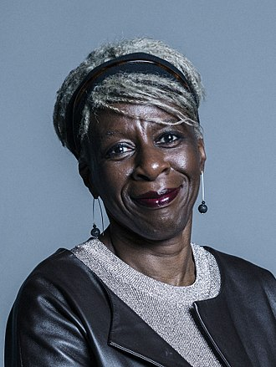
Margaret Omolola Young, Baroness Young of Hornsey OBE (born 1 June 1951) is a British actress, author, Crossbench peer, and Chancellor of the University of Nottingham.
She had been a residential social worker in the London Borough of Islington from 1971 to 1973. She then worked as a professional actress from 1976 to 1984, and presented a number of BBC programmes aimed at young children such as Play School and, on Radio 4, Listening Corner and Playtime. Her most prominent role was as next-door neighbour Janey in children's sitcom Metal Mickey which ran from 1980 to 1983. In 1985, she became co-director and training and development manager at Haringey Arts Council, a post she held until 1989.
From 1990 to 1992, she was lecturer in media studies at the Polytechnic of West London, later becoming lecturer, senior lecturer, principal lecturer, Professor of cultural studies and in the end Emeritus professor at Middlesex University. In 1995 she published Fear of the Dark: Race, Gender and Sexuality in Cinema.
Lola Young became project director of the Archives and Museum of Black Heritage in 1997, she was Commissioner in the Royal Commission on Historical Manuscripts in the years 2000 and 2001, and Chair at Nitro Theatre Company in 2004.
She was appointed an Officer of the Order of the British Empire (OBE) in the 2001 New Year Honours for services to British Black History.
From 2001 to 2004 she was head of culture at the Greater London Authority, following which she was created a life peer on 22 June 2004 taking the title Baroness Young of Hornsey of Hornsey in the London Borough of Haringey.
Her other public appointments have included English Heritage's Blue Plaques Committee, membership of the board of the Royal National Theatre, the South Bank Centre, and the board of Governors of Middlesex University, chairing the Arts Council's Cultural Diversity Panel, and membership of the board of Resource, the Council of Museums, Archives and Libraries, and a commissioner on the Royal Commission on Historical Manuscripts. She has also chaired the judging panel of the Orange Prize for Fiction.

Commissioners for Culture and Local Government
 | Hasan Bakhshi is Director of the Creative Industries Policy and Evidence Centre, a Nesta-led, AHRC-funded research consortium of ten universities, charged with improving the evidence base for policies to support the UK’s creative industries. His work includes co-authoring the landmark Next Gen skills review of the video games and visual effects industries, which led to wholesale reforms of the school ICT curriculum in England, and the Manifesto for the Creative Economy, which sets out ten recommendations by which governments can help the creative economy grow. Prior to Nesta, Hasan worked as Executive Director at Lehman Brothers, as Deputy Chief Economist at the Foreign and Commonwealth Office and as an economist at the Bank of England. He has published widely in academic journals and policy publications on topics ranging from technological progress and economic growth to the economics of the creative and cultural sector. In the 2015 New Year’s Honours he was awarded an MBE for services to the creative industries. Hasan is a member of the government’s Creative Industries Council, the Department for Digital, Culture, Media and Sport's Science Advisory Council and Advisory Board for its Culture and Heritage Capital Framework. In 2017, he was elected to sit on the Royal Economic Society Council. He sat on the ABRSM’s Music Commission which published its findings in 2019 and Community and the Fabian Society’s Commission on Workers and Technology which reported in 2020. Hasan currently serves on the board of two arts organisations: Art UK and Darbar Arts.
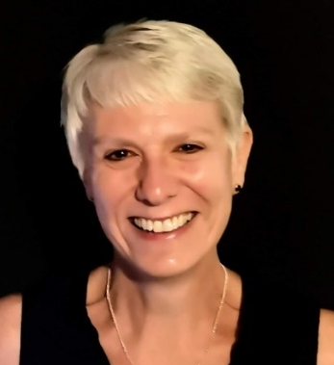 | Val Birchall is past Chair of the Chief Culture & Leisure Officers Association (CLOA). She is the association’s Equality Champion, driving towards a more diverse and inclusive leadership model in the sector. Val has led culture, tourism, events and sport services in local government for nearly two decades, working at Birmingham, Brighton & Hove and Coventry City Councils and has experience running services ranging from communications to the creative industries, digital, community development and sustainability. She was an Expert City Coach for the European Commission’s Culture for Cities and Regions programme and has worked as a consultant and lecturer in cultural policy. Val is a Fellow of the Royal Society of the Arts and on the board of Talking Birds Theatre Company. She is currently researching into the implications for cultural policy makers of emerging experimental models of local governance.
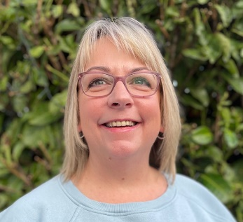 | Derri Burdon is the Chief Executive of creative education charity Curious Minds. As the Arts Council England Appointed Bridge organisation for the North West, Curious Minds works to place creativity and culture at the heart of schools and other services for children and young people. She originally trained as a teacher and taught English in further education colleges. She went on to work for ten years as part of Bolton Council’s Educational Improvement Service where she was responsible for leading several high-profile education and regeneration initiatives including: Find Your Talent, Inspiring Communities, Bolton UFA and Sunflower Clubs. School wasn’t her favourite place as a child but despite this (or likely because of it) Derri is passionate about improving learning outcomes for all children, especially the most disadvantaged and vulnerable. In her current role, she is driven by the passionate belief that rather than attempting to ‘close the gap’, we should be filling it brim-full with enriching and inspirational cultural and collective experiences that the most fortunate families take for granted. A proud Blackpudlian with Irish roots, she graduated from the University College of St Martin where she studied English Literature and Drama. She is a Governor of a secondary school in Wigan and is Chair of the newly formed CIO ‘Blaze Arts’, as well as Co-Chair of the Cultural Learning Alliance.
 | Corey Campbell is the Artistic Director of Strictly Arts Theatre Company. Through productions such as Green Leaves Fall and the critically acclaimed, Edinburgh sell-out show Freeman, Strictly Arts have used their collaborative, devising process to bring stories from real people to the stage. Corey’s flagship production for the City of Culture year is a powerful new digital TV series called SeaView. This family drama, with an unsettling supernatural element, is rooted in the experiences of Black, working class communities in the West Midlands. Driven by a desire to develop a new vision and way of working for a 21st century Theatre, Corey Campbell, Balisha Karra and Justine Themen were appointed as Co-Artistic Directors of the Belgrade Theatre in Coventry for 2021, bringing with them a unique perspective that celebrates Coventry’s diversity and drive for positive change. Corey will now take that legacy forward with his new appointment. He was promoted to Creative Director in December last year.
 | Nathan Geering specialises in accessibility innovation and strives to make work that heightens accessibility for both disabled and non disabled artists and audiences. He was the Artistic Director of the 2017 Special Olympics Opening Ceremony and is the founder of the multi-award winning Rationale Method of Audio Description. He also runs a registered charity called Rationale Arts. In 2021 Nathan became the Co-Artistic Director of Theatre Deli and oversees the Artistic Vision of both London and Sheffield venues. With this appointment Nathan and his colleague Ryan Harston made history because for the first time Theatre Deli's Artistic Vision is now Black Lead. Nathan is also part of the Sheffield Race Equality Commission and champions racial equality and diversity within the arts and beyond.
Cllr Peter Golds CBE has served as a London councillor for twenty four years, including sixteen years on Tower Hamlets Council, where he is Leader of the Conservative Group. He has been active on London Councils as well as the LGA. For eight years he has been a member of the Culture Tourism and Sports (CTS) Board at the LGA, currently serving as Deputy Chair. He will be representing the CTS Board on the Commission and ensuring that perspectives from Board are reflected on the Commission. He has a lifelong interest in the arts and in particular music, opera and the theatre and sits on the Board of Directors for the Green Candle Dance Company.
He is also closely involved in local work on sports development and is a Director of Island Sports Trust, a voluntary organisation which manages and facilities community use of sporting facilities and sports development for students.
Peter grew up in a non-prosperous area of London and is committed to ensuring the arts are there for all.
 | Veda Harrison is Director of Creative Confident Communities/ A Fairer Future at the Esmee Fairbairn Foundation. She has worked extensively in the cultural, community and corporate sector, including with the Money and Pension Service on vulnerability, gender and racialised communities’ economic equality and financial wellbeing, at NatWest Group in Sustainability and Corporate Affairs, leading engagement with charity partners, with the Stephen Lawrence Charitable Trust, NESTA and UK Youth, leading programmes on young people's creative and cultural development across the UK, at the Royal Borough of Greenwich/Charlton Athletic Race Equality Partnership designing and delivering community cohesion initiatives, and with the Southbank Centre Participation team and London International Festival of Theatre (LIFT). She is Vice Chair of Tramshed Arts in Woolwich and Fellow of the RSA.

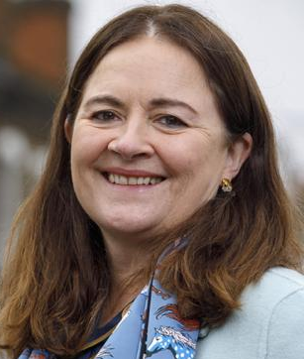 | Eilish McGuinness has worked in heritage all her professional life and has extensive experience across the sector and the breadth of the UK’s heritage. She joined the Fund in 1996 where she has held a variety of roles, both operational and strategic.  Before taking up her current role as CEO in January 2022, she was Executive Director of Business Delivery. Eilish’s department has been among many staff at the Heritage Fund working at the frontline with heritage organisations to support them through the pandemic. From the start of the pandemic, until the end of this financial year, the fund will have invested around £675million, about £100m more than we would have invested in the same period normally. This has provided vital support to heritage organisations. Eilish has a strong commitment to the power of heritage to support communities, strengthen economies and to change lives.  Eilish has a degree in History of Art and Archaeology from University College Dublin, and an MA from Queen’s University Belfast, where she was a junior research fellow in the Institute of Irish Studies. She has also worked in the heritage sector in Ireland, Northern Ireland and Scotland.
Samantha Richardson MBE has directed the research, visitor experience, training and communications programmes of the Academy since its launch in 2013. She also oversees the “England’s Coast” project, which focuses on attracting new international and domestic visitors to our stunning coastline year-round.
Sam’s work focuses on national engagement and partnerships that will help boost the visitor economies of coastal communities, with a particular emphasis on addressing seasonality and raising awareness of key issues impacting coastal tourism in England.
Sam has a postgraduate degree in Tourism Management and over 20 year’s experience in the industry. Samantha was awarded an MBE in the New Year’s Honours List in 2022 in recognition for services to England’s coastal tourism and supporting destinations through the pandemic.
Petra Roberts is Cultural Development Manager at Hackney Council. In April 2021, Petra was appointed to lead a review of Hackney’s Libraries Service which is the first formal library review in a number of years that will inform a new Library strategy in 2022.
During the Covid lockdown, Petra co-led the Cultural development team and provided business and fundraising support to local arts organisations at risk. She also led the Mayor’s heritage review into the naming of landmarks, streets and public spaces in response to the resurgence of the Black Lives Matter movement.
In 2018, Petra initiated a philanthropic legacy project that will see the installation of the first permanent sculptures to honour the Windrush generation in two prominent locations – including large nine feet figures that will stand outside Hackney town hall and a series of fruit sculptures situated in the town centre. She is working with internationally renowned artists Thomas J Price and OBE Veronica Ryan. The project forms part of the award-winning Windrush engagement programme – founded by Petra – designed to help address social isolation and foster greater community cohesion and equality.
Other initiatives that Petra has led on include the award-winning Discover Young Hackney initiative, running since 2006 and engaging thousands of local people with arts and culture – many for the first time. Previously to local government, Petra worked in various roles in the VCS sector, the cultural and creative industries, the National Health Service and as a grantmaker at the National Lottery Fund.
 | Bobby Seagull is a school maths teacher, author and TV presenter and came to public prominence after captaining Emmanuel Cambridge on University Challenge. Before moving into education, he was an investment banking trader at Lehman Brothers & Nomura, and is a qualified Chartered Accountant from PwC. He is a charity ambassador for National Numeracy and the Reading Agency and former CILIP Libraries Champion. He is a columnist for the Financial Times, author of The Life-Changing Magic of Numbers and co-presenter of the podcast Maths Appeal. He co-wrote The Monkman & Seagull Quiz Book and co-presents the BBC TV series Monkman & Seagull’s Genius Adventures. He is also quiz host for Channel 4's The Answer Trap.
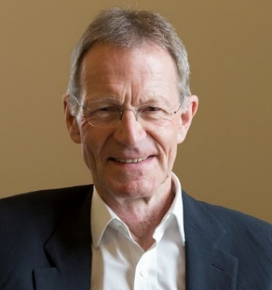 | Sir Nicholas Serota has been Chair of Arts Council England since February 2017 and is a member of the Board of the BBC. He is currently Chair of the Durham Commission on Creativity and Education.  He was Director of Tate between 1988 and 2017. During this period Tate opened Tate St Ives (1993) and Tate Modern (2000 & 2016), redefining the Millbank building as Tate Britain (2000). Tate also developed its national role by creating partnerships with regional galleries across the UK in the Plus Tate network. Between 2008 and 2017 he led the work on ‘Greening Museums’ for the Bizot Group of international museums.
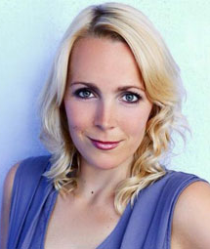 | Professor Katy Shaw leads research into twenty-first century writings at Northumbria University. Her research interests include contemporary literature, especially working class literature, cultural representations of post-industrial regeneration and the languages of comedy. Katy is an expert in twenty-first century literature. She has produced two books on crime author David Peace, a monograph on representations of the Credit Crunch in contemporary culture, and a collection on the teaching of twenty-first century genre fiction. Her latest book Hauntology (2018) explores the persistent role of the past in the present of contemporary English Literature. She is a public intellectual, literary festival host, media presenter and Twitterer. She was the lead author of the Northern Culture APPG’s recent report The Case for Culture.
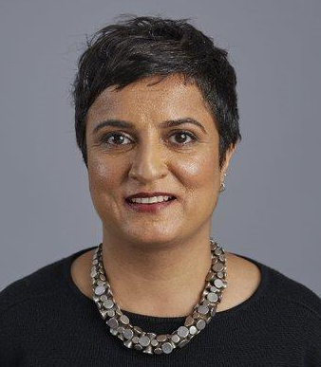 | Sara Wajid MBE is Co-CEO of Birmingham Museums Trust, alongside Zak Mensah – this job-share CEO partnership is a first in the museum sector and signals Birmingham Museum Trust’s commitment to inclusive working practices. Sara was formerly Head of Engagement at Museum of London and Head of Interpretation at Birmingham Museum and Art Gallery in 2017. Before working in museums she was a cultural commentator, journalist and editor. She is a trustee of the Pitt Rivers Museum, a judge of the Museum Activism award, a member of the Museum Detox network for people of colour in museums and an active advocate for diversity and equality issues in the arts.
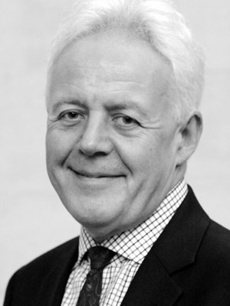 | Duncan Wilson OBE joined Historic England as the organisation’s first Chief Executive on 1 April 2015.  Historic England is a public body which improves people’s lives by protecting and championing the historic environment.  Previously, Duncan was Chief Executive of the Alexandra Park and Palace Trust, developing a major regeneration and conservation scheme to restore the Victorian theatre and television studios. He has also been Chief Executive at the Greenwich Foundation for the Old Royal Naval College, maintaining one of Europe's finest groups of baroque buildings, and the Somerset House Trust, opening the site to the public.  Duncan’s first job as a chartered accountant in 1987 was as Senior Management Accountant at English Heritage. Before accountancy he worked as a professional archaeologist in Oxford and Herefordshire, following post graduate research in European Archaeology.  Duncan is a Trustee of the Chatham Historic Dockyard Trust. He was awarded the OBE for services to heritage in 2007.

